**Component Description**

**MPU6050**

The MPU6050 is one of the most commonly used Sensor Modules by hobbyists and enthusiasts. It consists of Accelerometer and Gyroscope on the same IC and provides 6 Degrees of Freedom (3-axis of Accelerometer and 3-axis of Gyroscope).

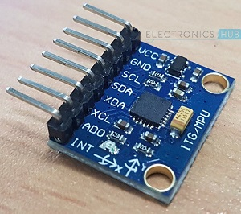

**RF Transmitter and Receiver Modules**

The communication between transmitter and receiver is using RF modules. A 434 MHz transmitter and receiver pair are used in this project.

**HT-12E**

It is an encoder IC that converts the 4-bit parallel data into serial data in order to transmit over RF link.

**HT-12D**

It is a decoder IC that converts the serial data received by the RF Receiver into 4-bit parallel data. This parallel data can be used to drive the motors.

### Working of Hand Gesture Controlled Robot

In this project, a mobile robot that is controlled by the gestures made by the hand, is designed. The working of the robot is explained here.

As mentioned earlier, the gesture controlled robot is a wireless operated robot and has two parts: Transmitter and Receiver. When the robot is powered on, the transmitter part, which consists of Arduino, MPU6050, Encoder and RF Transmitter, will continuously monitor the MPU6050 sensor.

This data is captured by the Arduino, which then transmits a corresponding data to the Encoder, based on the orientation of the MPU6050 Sensor. The parallel data received by the encoder is converted into serial data and this serial data is transmitted by the RF Transmitter.

At the receiver section, the RF Receiver receives the serial data and transmits it to the Decoder IC. The Decoder will convert the serial data to parallel data and this parallel data is given to the motor driver IC. Based on the data, the movement of the motors, and hence the movement of the robot is defined.